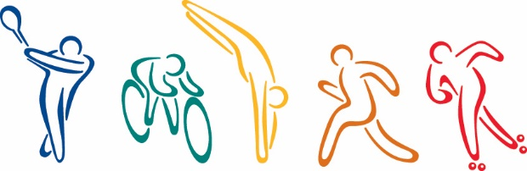Sports Connection

Overview

Sports Connection

Overview

This document summarizes how the old New Orleans Park and Recreation Center is being transformed into the new Sports Connection facility. It also describes the relationship between Sports Connection and the Community Foundation.

# Community Foundation

The Community Foundation created the Sports Connection as a result of a $5 million donation from an anonymous donor. The sole purpose of the Community Foundation is to foster a better quality of life in the New Orleans community. It is a publicly supported non-profit organization that receives gifts from donors to make grants for local charitable purposes. Many of the gifts are designated as endowments.

Endowments provide a permanent source of income because the money is invested and only the earnings are spent. Donors may designate who receives the benefits and the conditions under which the proceeds may be used. Once a grant has been made to a non-profit organization, such as the Sports Connection, the Community Foundation must ensure that the expenditure of funds meets the criteria established by the donor. This oversight is accomplished by an established reporting procedure and by having an *ex officio* representative on the governing board, the Sports Connection Advisory Council.

# Sports Connection Mission

The mission of Sports Connection is to promote good sportsmanship, fitness, good health, and recreational activities for young people in an environment that enhances good community relations. Sports Connection especially seeks to ensure that young men and women are an integral part of the activities provided by Sports Connection.

# Sports Connection Site

The physical facility consists of a park and a converted school that was vacated when schools were consolidated. The vacated school had a gymnasium, a cafeteria, several large classrooms, an office suite, and several large restrooms. The area of the park designed to appeal to very young children has a playground with outdoor equipment and a large open area used for organized activities, such as T-ball, soccer, and other sports. The area of the park designed to appeal to teenagers and young adults is near the recreational facility and has a swimming pool, several tennis courts, and several acres of land used for baseball, soccer, and softball.

# Criteria for Establishing Sports Connection

Twenty years ago, the donor’s father anonymously gave to the city the park and recreational facility. The entire $5 million donation must be used to enhance the facility and programs offered there. The appropriate city officials approved the new gift and agreed to continue maintaining the park and recreational facility by providing basic maintenance, insurance, utilities, and security. The gift agreement specifies the following criteria:

* Of the $5 million gift, $3 million must be placed in an endowment in the Community Foundation, which will invest the money and distribute 5 percent of the endowment each year to Sports Connection provided the earnings are adequate to do so. The remaining earnings are added to the endowment so that it continues to grow.
* The remaining $2 million is to be used to upgrade and equip the indoor sports facility and the park area and to cover the operational budge for the first year since earnings will not be available during the first year.
* An Advisory Council with diverse representation will oversee the financial and operational activities of Sports Connection.
* All aspects of Sports Connection must be available at no charge to young people who are financially disadvantaged (as determined by the Community Foundation guidelines).
* The facilities and activities must be designed to appeal to young women as well as to young men, and the Advisory Council must demonstrate that appropriate resources are allocated to ensure that young women are an integral part of Sports Connection.
* The Advisory Council should solicit corporate sponsorships, donations, and volunteers to enhance the operations of Sports Connection.
* Efforts must be made to introduce all youth to sports and activities that are often available only to the more affluent segments of society.
* Educational activates—particularly as they relate to fitness and health—as well efforts to build good sportsmanship must be an integral part of Sports Connection.
* Efforts must be made to publicize Sports Connection to make the community aware of the resources it provided for youth.